CCA ACHIEVEMENTS
- The Vidyalaya secured the Second Position in the region by the Regional Selection Committee for running trophies for the most NEAT & CLEAN KV.
- The team of Kendriya Vidyalaya Babina Cantt. participated in the Regional Level Youth Parliament 2018 held at KV Noida from 10th to 12th September 2018 and won the first position.
Then they participated in the Zonal Level Youth Parliament 2018 held at KV ONGC Chandkheda, Ahmedabad from 26th Nov to 28th Nov 2018. Competing against strong teams of Mumbai, Ranchi, Ahmedabad and Jaipur regions, our students managed to secure the third position.
- Cluster Level ‘Ek Bharat Shreshtha Bharat’ Camp (erstwhile called Social Science Exhibition) 2018 was held at KV No. 3 Jhansi from 5th Sept to 7th Sept 2018 in which our following students got positions.
CLUSTER LEVEL: PARTICIPANTS AND POSITIONS
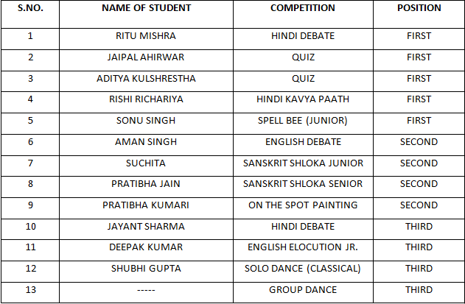
- The following students of our Vidyalaya represented Jhansi cluster in EK BHARAT SHRESHTH BHARAT Regional Level Competition.

WINNERS (1ST POSITION HOLDERS) OF REGIONAL LEVEL
Ritu Mishra – Hindi Debate
AdityaKulshreshtha and JaipalAhirwar – Quiz
Rishi Richariya – Hindi KavyaPaath
Sonu Singh – Spell Bee Junior
- The following students of our Vidyalaya represented Agra Region in EK BHARAT SHRESHTH BHARAT National Level Competition.
PARTICIPANTS OF NATIONAL LEVEL
Ritu Mishra – Hindi Debate
AdityaKulshreshtha and JaipalAhirwar – Quiz
Rishi Richariya – Hindi KavyaPaath
- The Vidyalaya has been awarded by Rajbhasha Kriyanavan Samiti of KVS RO Agra Region for 100% documentation in Hindi Language in all its correspondence with KVS.

