‘Ek Bharat Shreshtha Bharat’
Cluster Level ‘Ek Bharat Shreshtha Bharat’ Camp (erstwhile called Social Science Exhibition) 2018 was held at KV No. 3 Jhansi from 5th Sept to 7th Sept 2018 in which our following students got positions.
CLUSTER LEVEL: PARTICIPANTS AND POSITIONS
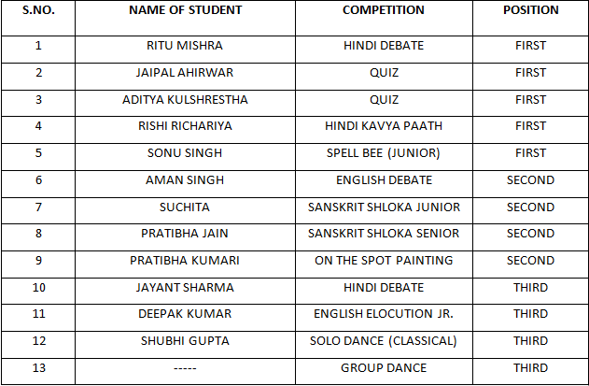
- The following students of our Vidyalaya represented Jhansi cluster in EK BHARAT SHRESHTH BHARAT Regional Level Competition.
WINNERS (1ST POSITION HOLDERS) OF REGIONAL LEVEL
Ritu Mishra – Hindi Debate
Aditya Kulshreshtha and Jaipal Ahirwar – Quiz
Rishi Richariya – Hindi Kavya Paath
Sonu Singh – Spell Bee Junior
- The following students of our Vidyalaya represented Agra Region in EK BHARAT SHRESHTH BHARAT National Level Competition.
PARTICIPANTS OF NATIONAL LEVEL
Ritu Mishra – Hindi Debate
Aditya Kulshreshtha and Jaipal Ahirwar – Quiz
Rishi Richariya – Hindi Kavya Paath
- The Vidyalaya has been awarded for 100 % documentation in Hindi Language in all its correspondence with KVS by AGRA Region.

